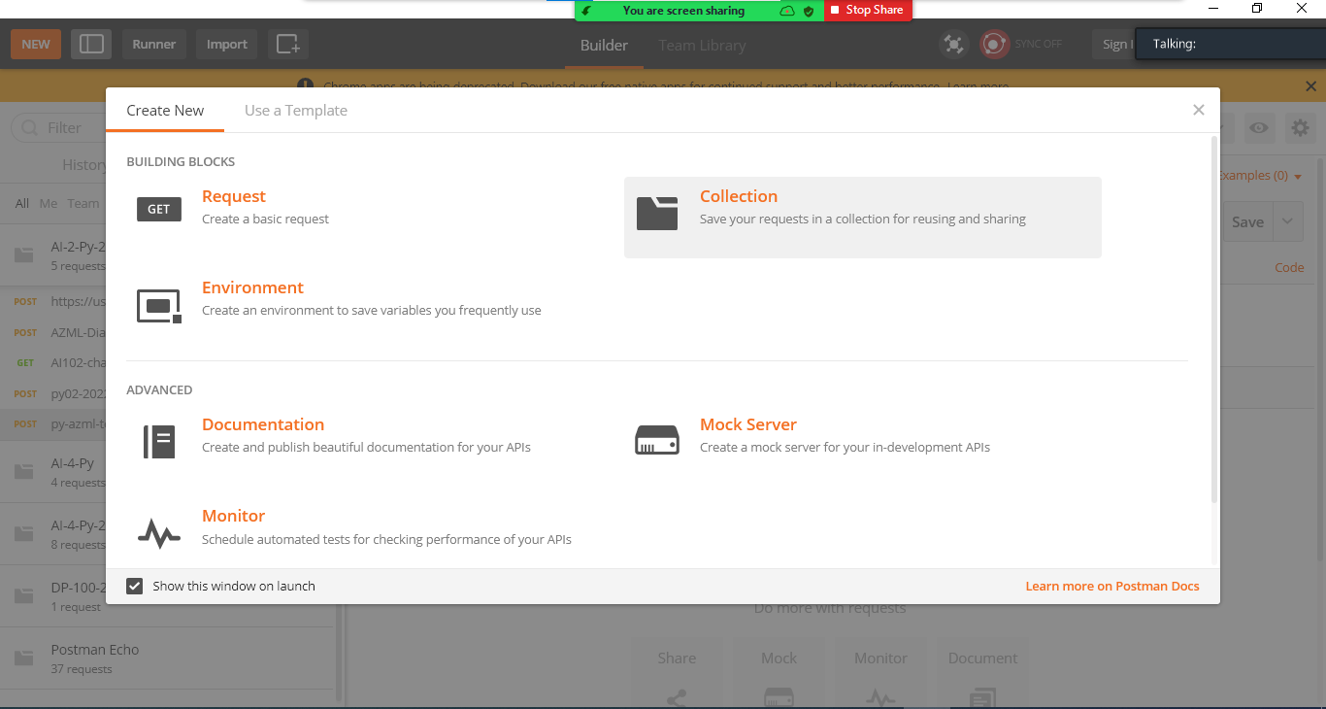

<https://www.postman.com/downloads/>

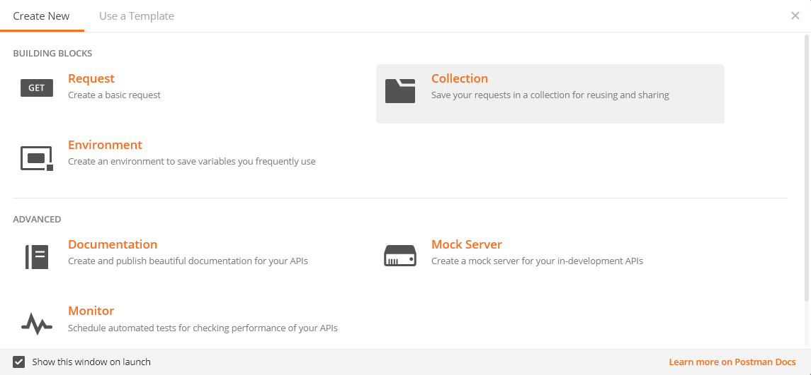

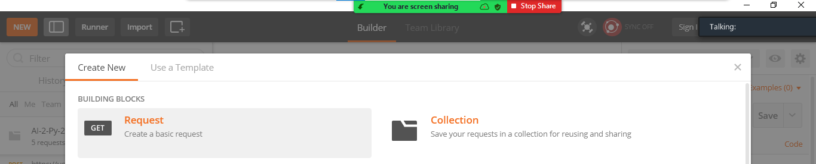

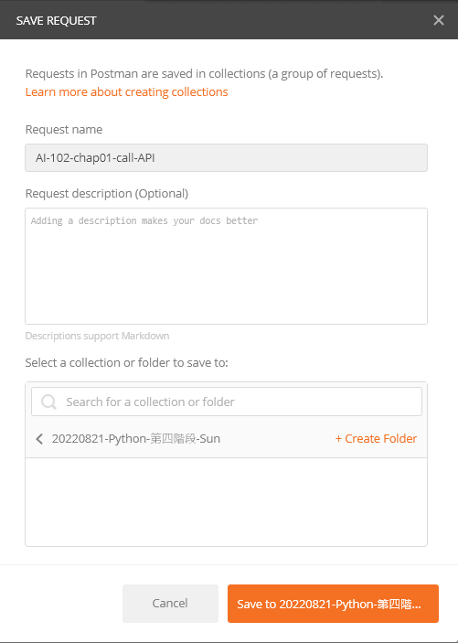

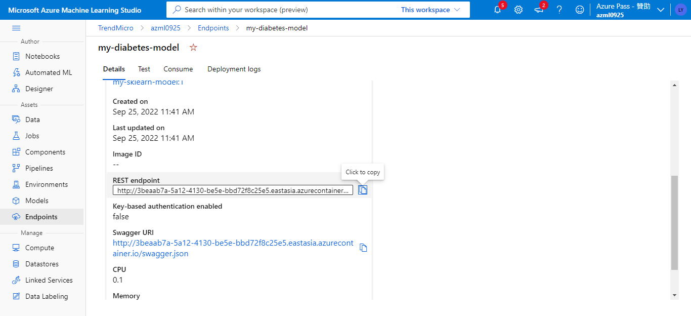

<http://3beaab7a-5a12-4130-be5e-bbd72f8c25e5.eastasia.azurecontainer.io/score>

Content-Type application/json

Authorization Bearer

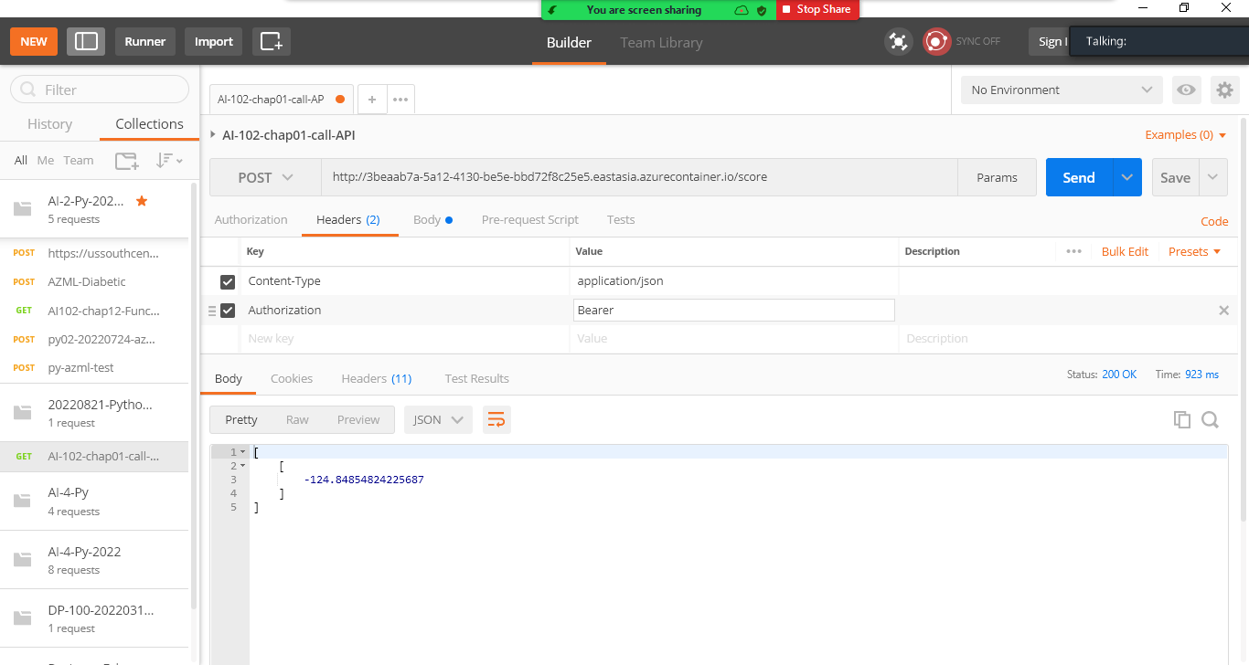

此處有空格

{

"data": [

{

"AGE": 5,

"SEX": 2,

"BMI": 3.1,

"BP": 3.1,

"S1": 3.1,

"S2": 3.1,

"S3": 3.1,

"S4": 3.1,

"S5": 3.1,

"S6": 3.1

}

]

}

